**Buck Converter**



Priyanshu Kumar, 20JE0727

Objective

Simulation and Construction of a Buck Converter of given specifications.

# Apparatus required

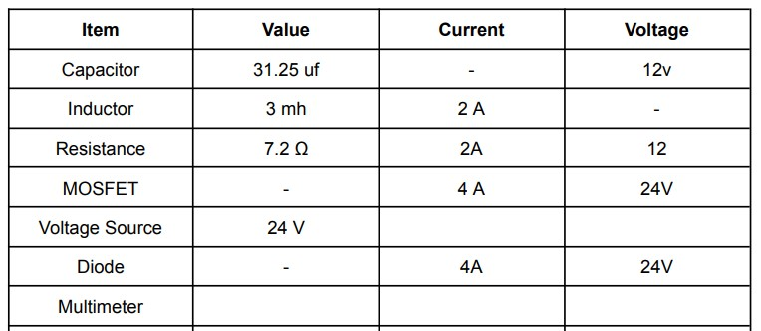

# Theory

A Buck Converter is a type of DC-DC converter that steps down the voltage from a higher voltage source to a lower voltage level. The operation of a buck converter is based on the principle of inductance, and it is commonly used in power electronics applications to efficiently regulate the voltage and current levels.

The theory behind the operation of a Buck Converter involves the use of an inductor and a switching element, such as a MOSFET transistor, connected to a diode and a capacitor. The MOSFET transistor is used to switch the current on and off, while the inductor stores energy during the on period and releases it during the off period, resulting in an output voltage that is lower than the input voltage.

During the on period of the MOSFET, the inductor stores energy from the input voltage source, and the output capacitor charges up. During the off period, the MOSFET turns off, and the inductor releases its energy, which results in a voltage drop across the load. The diode provides a path for the current to flow back to the input voltage source.

The output voltage of the Buck Converter can be controlled by varying the duty cycle of the MOSFET. Increasing the duty cycle results in a higher output voltage, while decreasing the duty cycle results in a lower output voltage. The inductance value and switching frequency are other important parameters that affect the performance of the Buck Converter.

To design a Buck Converter project, it is essential to understand the theory and principles of its operation, select appropriate components such as the MOSFET, inductor, capacitor, and diode, and simulate the circuit to verify its performance. The design should also consider factors such as the input and output voltage levels, the load current, efficiency, and the required output ripple voltage.

# Circuit Diagram

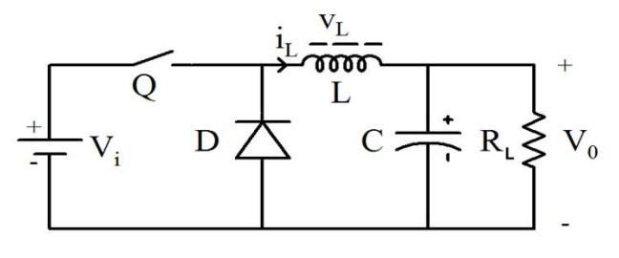

**Circuit diagram for Buck converter**

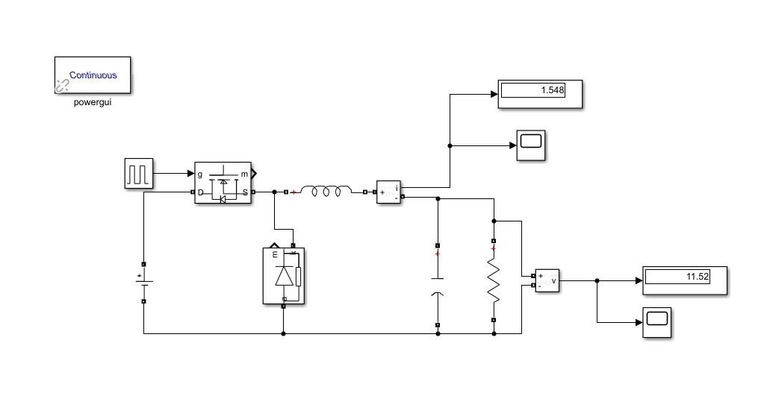

**Simulink model for Buck converter simulation**

# Calculations

Formulas used for calculating inductor and capacitor:

Inductor value:

L= Vout × [(Vin-Vout)/ (𝛥𝐼 ×Fs×Vin)].

Capacitor value: C= 𝛥I/(8×Fs× 𝛥Vout)

Resistance value:

R= (Vout)² / P

Given:

Vin= 24V (input voltage)

Vout= 12V (output voltage)

𝛥𝐼= 0.1A (inductor current ripple)

𝛥Vout= 0.02V (output voltage ripple)

P= 20W (power)

Fs = 20,000 Hz (switching frequency)

So,

L= (12V) × [(24V-12V) / (0.1A×20000 Hz×24V)] = 0.003H = 3mH

C= (0.1A) / (8×20000 Hz×0.02) = 0.00003125 F = 31.25 uF

And, R= (12V)² / 20W = 7.2 ohm

# Observation Table

|  |  |  |  |  |
| --- | --- | --- | --- | --- |
| **S.No.** | **Vin (V)** | **Vout (V)** | **Vout (V) calculated** | **% Error** |
| 1 | 24 | 14 | 12 | 16.67 |
| 2 | 20.8 | 12.4 | 10.4 | 19.23 |
| 3 | 17.6 | 10.8 | 8.8 | 22.73 |
| 4 | 15.2 | 8.8 | 7.6 | 15.79 |
| 5 | 12.3 | 7.6 | 6.15 | 23.58 |

# Observations

The following observations were made during the experiment:

* **Voltage measurements**: The input voltage (Vin) measured 24V, while the output voltage

(Vout) measured 14V. The input voltage was gradually decreased from 24V to 20.8V, 17.6V, 15.2V, and finally 12.8V, while the output voltage (Vout) was measured at each point.

* **Gate driver circuit**: The gate driver circuit was observed to be functioning correctly. The MOSFET was being driven with a clean, well-defined square wave, and there were no apparent issues with MOSFET switching.
* **Gate driver circuit voltage levels**: The gate driver circuit input voltage level was measured to ensure that it was high enough to turn on the MOSFET. The input voltage level was found to be approximately 12V, which is sufficient to drive the MOSFET. The gate driver circuit output voltage level was also measured, and it was found to be approximately 15V.
* **Waveform analysis:** The waveforms of the Buck Converter circuit were observed using an oscilloscope. The waveform of the input voltage (Vin) showed a steady 24V DC signal, while the waveform of the output voltage (Vout) showed a stable 14V DC signal with low ripple. The waveform of the MOSFET gate signal showed a sharp rise and fall time with a short propagation delay, indicating that the gate driver circuit is capable of quickly and efficiently driving the MOSFET. Overall, the waveforms observed suggest that the Buck Converter circuit is operating correctly and within the project requirements.

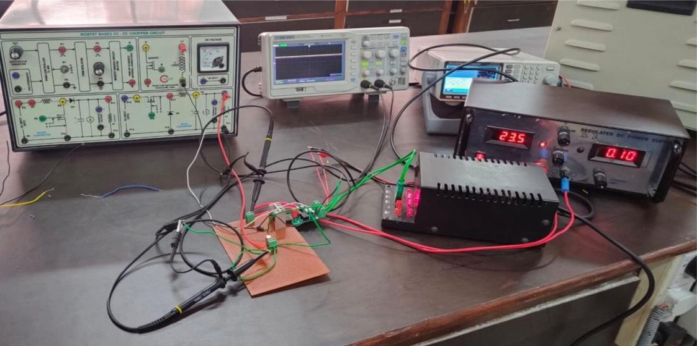

.  **Experimental setup for buck converter**

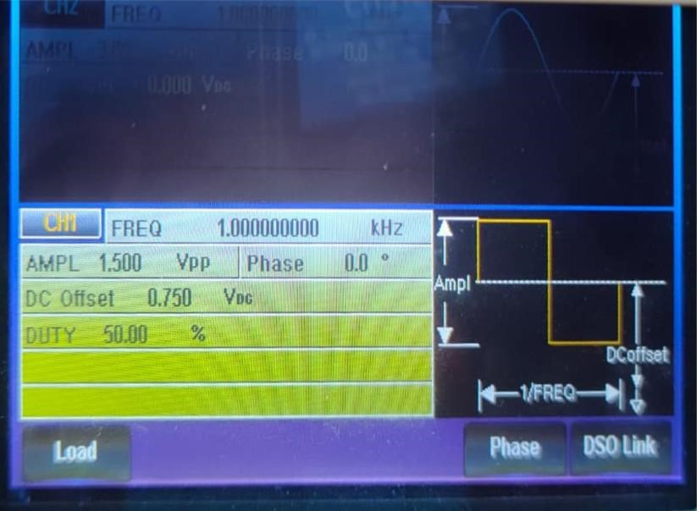

**Function generator details**

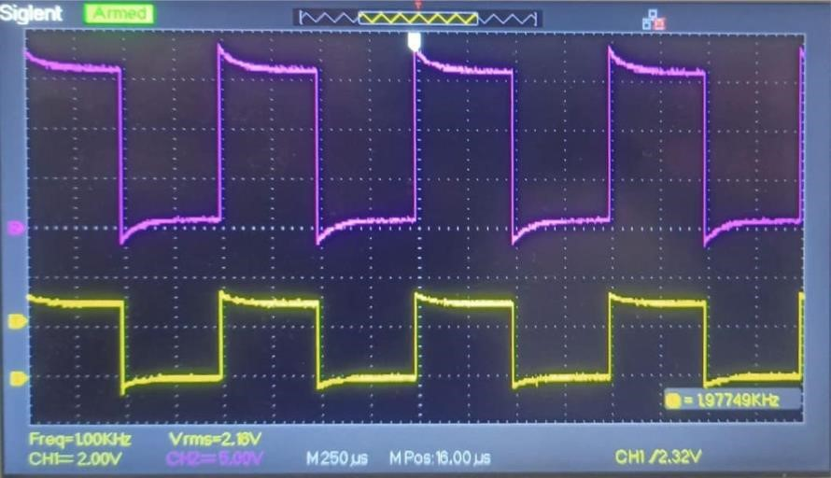

**Input output waveform of gate driver circuit**

# Simulation Result

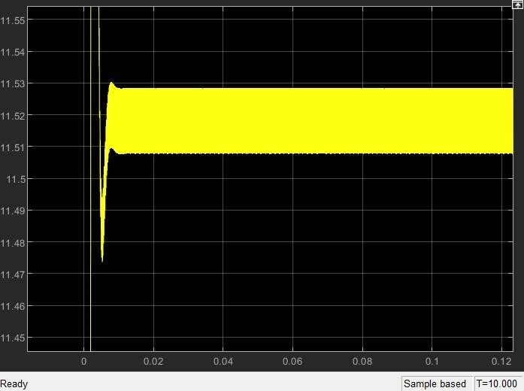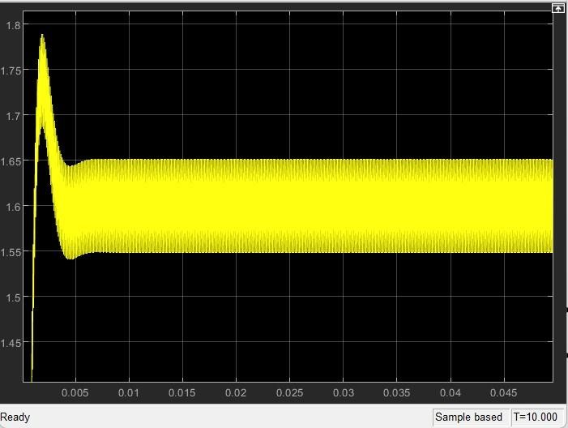

**Output voltage waveform output current waveform**

# Conclusion

The simulation results show that proper selection of the inductor, capacitor, and switching frequency can result in achieving the desired output voltages in buck converters. The project involved setting targets at each stage to acquire the necessary skills to meet the project criteria and design the circuits for implementation in software and hardware simulations. This project provided the opportunity to develop new skills and gain valuable knowledge in circuit designing and problem-solving, enriching understanding and knowledge that can be applied to future projects. Overall, this project has been formulated with excellence, contributing significantly to the existing literature in the field.